Introduction

In this report the main objective is to develop a web-based food delivery platform that offers a seamless experience for users to order food from various restaurants, track their orders in real-time, and provide feedback on their delivery experience. The platform should prioritize accessibility, usability, convenience, and reliability. The website that is going to be developed is a delivery app that is more towards cafes and western food using html, CSS and JavaScript language. This report will display the results of the methodology, development, challenges, and the design of the delivery app.
The idea for Cafe Dash came about due to the increasing demand for online ordering and delivery services, as well as the growing popularity of cafe culture worldwide. Extensive research was conducted to understand consumer behavior, market trends, and technological advancements in the food and beverage industry. Key words such as "online food ordering," "café management systems," and "user experience design" played a crucial role in shaping the project.

Project Design
Typography: Typography plays a crucial role in setting the tone and personality of the platform. Choosing appropriate fonts that are both visually appealing and easy to read enhances the overall user experience. Using the Open Sans font for Cafe Dash strikes a balance between modernity and readability. Its clean lines and contemporary appearance convey professionalism while ensuring easy legibility across different devices.
Images: High-quality images are essential for creating an immersive and enticing experience on the platform. Cafe Dash utilize a mix of professionally shot photographs to showcase café ambiance, menu items, and featured promotions. Images should be carefully curated to reflect the branding of the cafes listed on the platform, for users to explore further and place orders.
Themes: The Orange Theme for Cafe Dash gives off a feeling of warmth, liveliness, and a love for life, capturing the energetic and welcoming ambiance that is typically found in cafes. The color orange is often associated with creativity, enthusiasm, and sociability, making it a perfect choice for a cafe setting.
Colors: The color palette for Cafe Dash is warm earthy tones like #AF601A and accent colors such as #ffc107 adding vibrancy. These colors create visual coherence and reinforce the platform's identity. The light and dark brown hues (#EB984E and #6E2C00) add depth, resembling coffee beans and wooden furnishings. Consistency in color usage ensures brand recognition and a harmonious visual experience throughout the platform.
Overall Design: The main focus of Cafe Dash's design should be on simplicity, easy of use, and practicality. This can be achieved through clear navigation menus, noticeable call-to-action buttons, and user-friendly search features that help users easily find cafes, view menus, and place orders. Paying attention to details like spacing, alignment, and visual hierarchy ensures that the content is presented in an appealing and easy-to-understand way, which improves the overall user experience and engagement.

Development
This delivery app has utilised Hypertext Markup language, Cascading Style Sheets and JavaScript. The reason for the chosen program is for the program’s functionality and effectiveness. The programs were able to showcase the desired design for the website.

HTML (Hypertext Markup Language)
HTML is a coding language that is commonly used to create the layout and content of web pages. In Cafe Dash, HTML is used to define how each page on the website is structured, including things like headings, paragraphs, lists, links, and other elements. It is essential for presenting information to users and organizing the different parts of the website's interface. For instance, HTML is used to design the homepage, showcase restaurant listings, display menu items, and set up the checkout process.

CSS (Cascading Sheet Style)
CSS, or Cascading Style Sheets, is a coding language that is used to control the design and layout of HTML elements on a webpage. It allows developers to customize the appearance of a website by specifying details such as colors, fonts, spacing, and layout. In Cafe Dash, CSS is used to style the various elements of the website, ensuring a consistent and visually appealing design across all pages. For example, CSS can be used to set the colors and typography styles, arrange elements on the page, and make the site responsive to different screen sizes and devices. By using CSS, developers can create a cohesive and attractive interface for users to interact with.

JavaScript
JavaScript is a coding language that is utilized to introduce interactivity and dynamic behavior to websites. In Cafe Dash, JavaScript plays a crucial role in improving user engagement by incorporating interactive elements and functions. It allows for real-time updates, validation of forms, manipulation of the Document Object Model (DOM), managing events, and communicating asynchronously with the server.

Implementation
Homepage:
The homepage of the website has a banner image that shows the cozy atmosphere of a café. It has a search bar for users to easily find specific cafes or menu items. Featured café listings are shown, along with links to popular sections like restaurant listings, menu display, and order tracking.
Moreover, inside the homepage also include restaurant listing page that displays a grid or list of café listings. Each listing includes a small image of the café, the name, rating, and a short description. Users have the ability to filter and organize the listings based on different criteria such as type of cuisine, location, or rating.

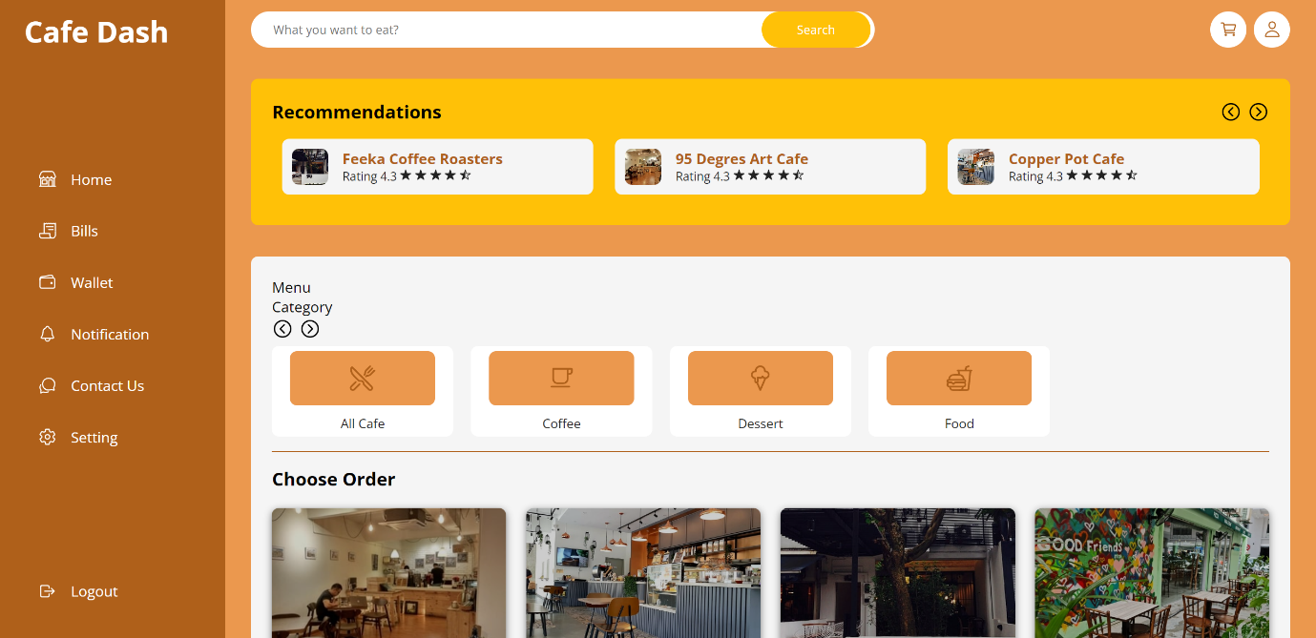

Menu Listing:
The menu display page shows the different food and drink options available at a specific café. The items are grouped into categories like drinks, dessert, and dishes. Each item on the menu has a description, price.

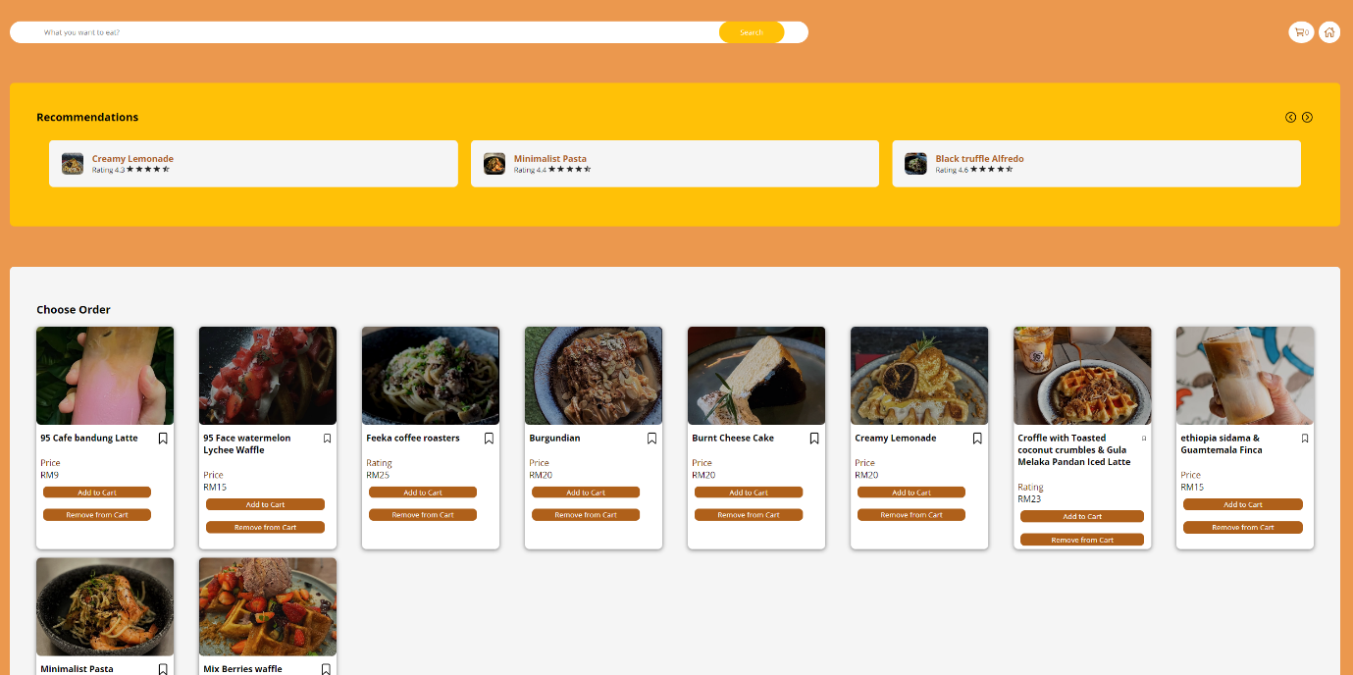

Checkout Process: The checkout process is a series of steps that help users select items, customize preferences, enter delivery details, and make payment. Progress indicators and clear instructions make it easier for users to complete their orders smoothly and efficiently.
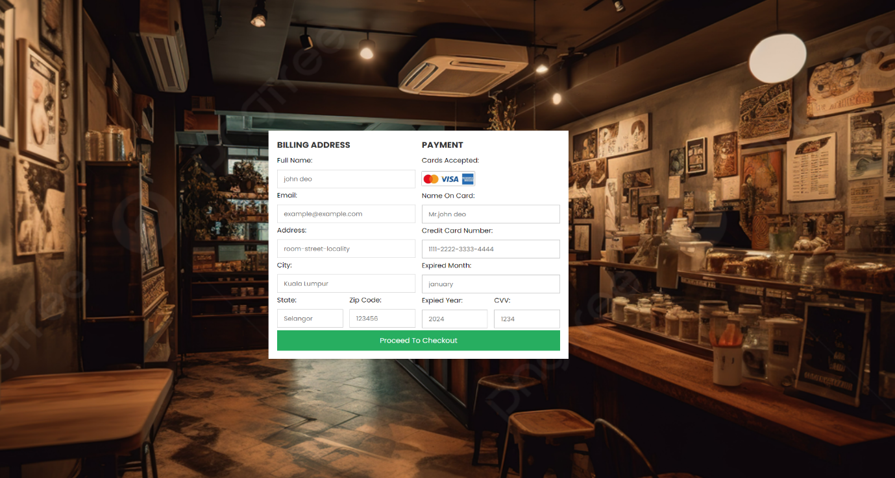
Order Tracking: The order tracking page enables users to keep an eye on the progress of their orders in real-time. Information is continuously updated, starting from order confirmation, through preparation, and all the way to delivery, ensuring that users are kept informed at every step of the process.

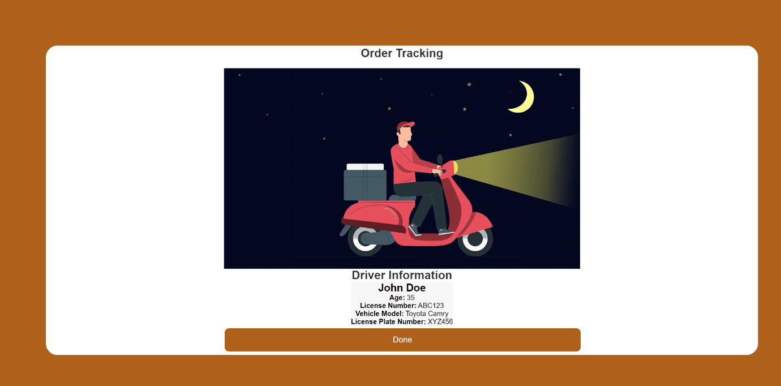

Conclusion
In conclusion, Cafe Dash represents a major improvement in the way food can be ordered online and how cafes can be managed. It provides a smooth and pleasant experience for both customers and cafe owners. The platform has been carefully developed through detailed research and creative design, with a focus on making it easy to use, convenient, and reliable. By utilizing modern web technologies such as HTML, CSS, and JavaScript, Cafe Dash provides a user-friendly interface that makes it easier for customers to find, order, and enjoy items from cafes. Collaborations with local cafes and functionalities like order tracking and customer feedback systems benefit both the cafes and the customers.
Moreover, Cafe Dash provides a convenient and easy-to-use online food delivery platform that focuses on being accessible and reliable. Our future plans involve adding more features like the ability to customize meals, connect with social media, and collaborate with local businesses to provide special offers.

References:

(Case Study: Food Delivery App Design | by Chinwe Uzegbu | Medium, n.d.)
https://cuzegbu.medium.com/ux-case-study-food-delivery-app-design-2a001c78db96

(Case Study: Designing a Food Delivery App from Scratch | by Marvis Dosa | Bootcamp, n.d.)
https://bootcamp.uxdesign.cc/designing-a-food-delivery-app-from-scratch-a-ux-case-study-82fd100f4e6a

(HTML Tutorial, n.d.)
https://www.w3schools.com/html/default.asp

(CSS Tutorial, n.d.)
https://www.w3schools.com/css/default.asp

(JavaScript Tutorial, n.d.)
https://www.w3schools.com/js/

